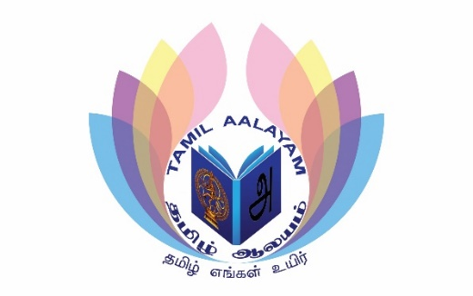
Luton & Dunstable Tamil Aalayam
Registration Form (use only capital letters)
Father’s Name (in English): |  | Father’s Name (in Tamil):
Mother’s Name (in English):
Child 1 |  | Photo Consent: Please Circle | Yes / No
GP Details |  | Allergies
Name (in English): |  | Name (in Tamil):
Tamil Grade: |  | Date of Birth
Dance Grade: |  | Music Grade:
Miruthangam Grade:

Child 2 |  | Photo Consent: Please Circle | Yes / No
GP Details |  | Allergies
Name (in English): |  | Name (in Tamil):
Tamil Grade: |  | Date of Birth
Dance Grade: |  | Music Grade:
Miruthangam Grade:

Child 3 |  | Photo Consent: Please Circle | Yes / No
GP Details |  | Allergies
Name (in English): |  | Name (in Tamil):
Tamil Grade: |  | Date of Birth
Dance Grade: |  | Music Grade:
Miruthangam Grade:

Father Phone no: |  | Mother Phone No:
Preferred whats app Contact no: |  | Please note: All school Communication will be via Whatsapp School group and Email so please provide this, as it is mandatory
Full Address
Email Address

Parent/Guardian Signature: Date:

